

Lesson Plan
Polly the Polar Bear Sleeps Well

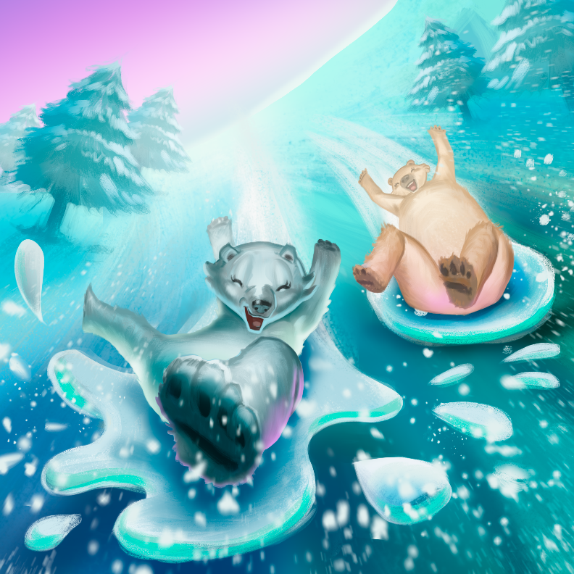

This lesson plan was produced by the CO2 Learning Center project and the CO2 Coalition

Table of Contents
Student Learning Goals 3
Background Information 3
References 13
Suggested Activities 13
Formative and Summative Questions 15
Next Generation Science Standards 15

A note about our lesson plans:
Our CO2 Learning Center lesson plans all have the same format, which include student learning objectives, background information on the science concepts covered in the book or video, suggested activities including labs to enrich the lesson and reinforce use of the scientific method, formative and summative questions, and learning standards from the Next Generation Science Standards (NGSS).
This lesson plan was created by the CO2 Coalition’s Senior Education Advisor Sharon Camp, Ph.D., Analytical Chemistry; B.S., Geology, using Next Generation Science Standards (NGSS).
The NGSS are the standards on which most public-school systems have based their curriculum. We do not necessarily endorse the NGSS but have included the relevant standards for circumstances in which a teacher is required to use them. The lesson plans contain everything that a teacher might be required to submit in a formal lesson plan to a school administrator or science department head.
Understanding NGSS:
LS: Life Science

PS: Physical Science
ESS: Earth and Space Science
1-5 indicates standard for grade level (1-first grade, 2-second grade, 3-third grade, 4-fourth grade, 5-fifth grade). MS indicates Middle School.

Please note that for Polly the Polar Bear, grade-specific NGSS standards are included for Grades K, 2, 4, 5, and MS. Only the parts of the standards that are relevant to this lesson have been included. If LS and PS only (example from this lesson) are shown, these NGSS segments were included as relevant to this lesson for Life Science and Physical Science.


Lesson Plan: Polly the Polar Bear Sleeps Well
Grades K - MS

Student Learning Goals
After reading the book and studying the lesson plan, students will be able to:

- Explain how polar bears are different from other bears and identify where they live.
- Explain what the weather is like where polar bears live.
- Describe where a polar bear cub lives shortly after it is born.
- List what polar bears eat.
- Describe what features a polar bear has that allow it to survive during the harsh winters.
- Explain what time of year polar bears eat seals and why they are not available year-round.
- Explain why sea ice cover does not affect the bears’ diet during the summer months.
- Explain what plankton are, why they are important to the food chain, and why they grow more abundant with a reduction of summer sea ice.
- Explain why a computer model is less accurate than measured, empirical data.

Background Information

The Arctic, found within the Arctic Circle, is one of the harshest environments on Earth. Its actual boundary is debated, but all agree that it is centered on the geographic North Pole and receives no sunlight in winter and only sunlight in summer. The Arctic not only includes the polar ice cap, but it also includes parts of the US (Alaska), Canada, Russia, Greenland, and Norway. The ice on the land areas of the Arctic will usually melt in the summer.

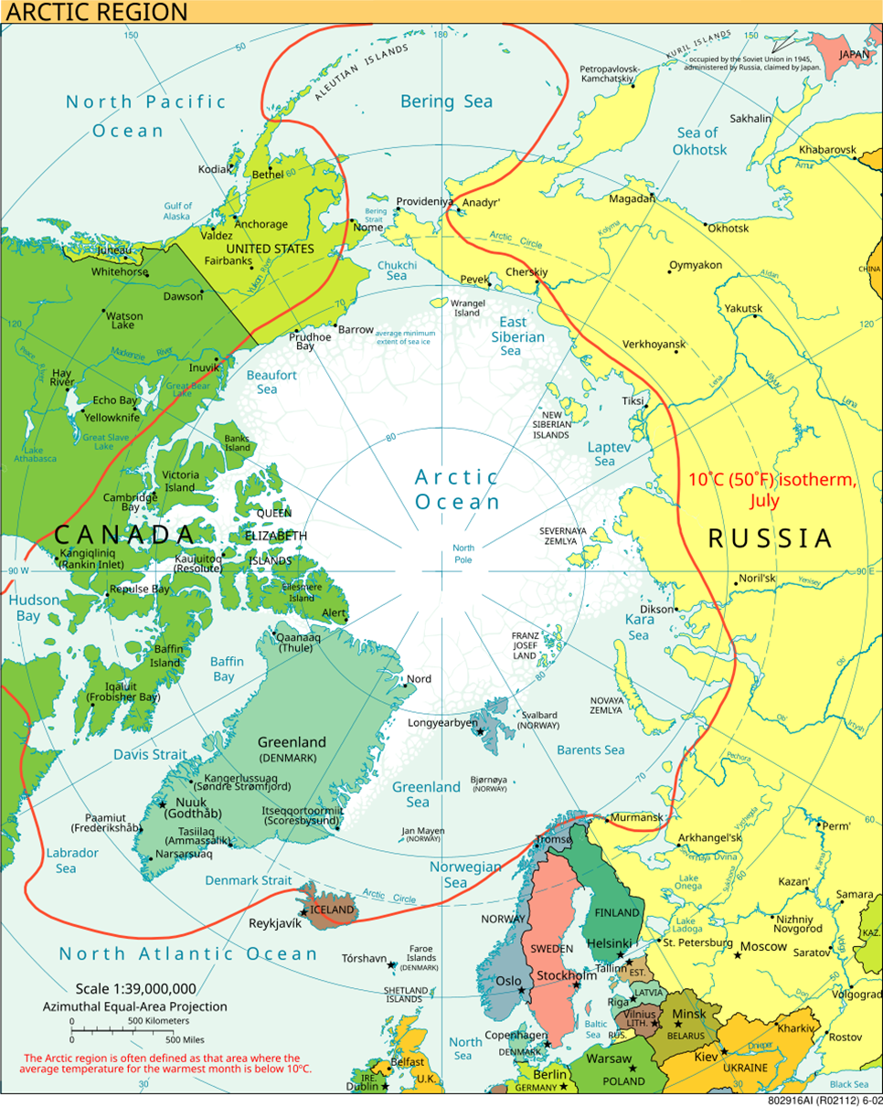

A view of the Arctic. The 10 °C (50 °F) mean isotherm in July line, displayed red, and is commonly used to define the border of the Arctic region. Source: CIA World Factbook, Public domain, via Wikimedia Commons. https://commons.wikimedia.org/wiki/File:Arctic.svg

In general, the mean temperature at the North Pole is 30.8 ⁰F (0.7 ⁰C) and stays below freezing for the months of October through April.¹ Thawing of the sea ice occurs around the boundaries of the Arctic Ocean in the summer, but sea ice remains frozen year-round in the center of the Arctic Ocean. Antarctica is colder than the Arctic primarily because warm tropical waters via the Gulf Stream get transported into the Arctic whereas the Antarctic Circumpolar Current prevents warm water from reaching the continent.

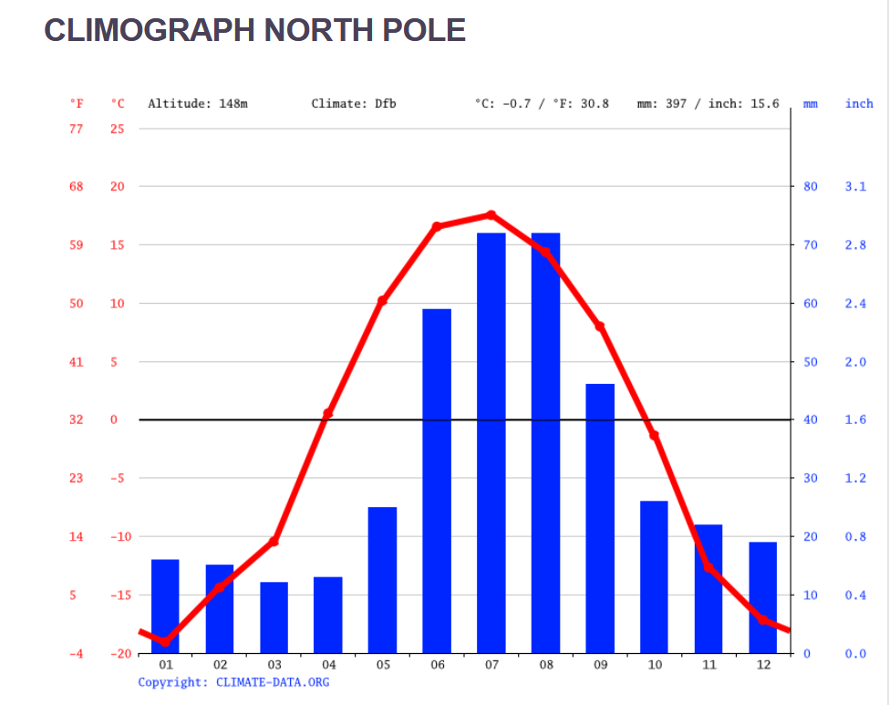

Source: https://en.climate-data.org/north-america/united-states-of-america/alaska/north-pole-15898/

Animals that live in the Arctic include polar bears, caribou, musk oxen, arctic foxes and hares, and ringed and bearded seals.

Polar bears are one of the largest species of bears, a title it shares with the Kodiak bear. The weight of a male polar bear ranges from 900 to 1600 pounds (400 to 700 kg).² A male polar bear is a little over 5 feet (1.5 meters) tall at the shoulder and can be as long as 8 feet (2.5 meters). It is a massive animal. Its fur is translucent, and sunlight can pass through it to warm the bear’s skin, which is black to maximize heat absorption. It also has a thick layer of fat under its skin to help it survive the incredibly cold winters in the Arctic.

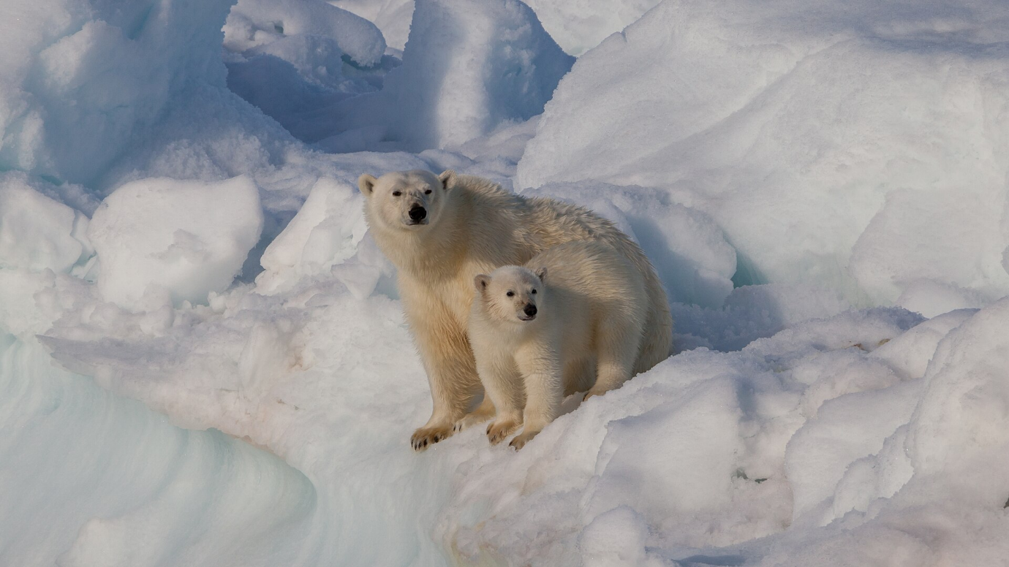

A female polar bear Ursus maritimus and its cub on dense drift ice in Hinlopen strait, Svalbard. Both mother and cub look well-fed and healthy since they obviously succeeded reaching the northern drift ice in spring in due time. Source: AWeith, CC BY-SA 4.0 <https://creativecommons.org/licenses/by-sa/4.0>, via Wikimedia Commons. https://commons.wikimedia.org/wiki/File:Female_polar_bear_(Ursus_maritimus)_with_cub,_Svalbard.jpg

Their population is estimated to be between 21,000 and 32,000, and are found in Canada, the US, Greenland, Norway, and Russia.

The map below shows the locations of polar bear subpopulations and ecoregions. The polar basin Divergent Ice Ecoregion (shown in purple) includes the Southern Beaufort Sea (SBS), Chukchi Sea (CS), Laptev Sea (LVS), Kara Sea (KS), and the Barents Sea (BS). The polar basin Convergent Ice Ecoregion (shown in blue) includes East Greenland (EG), Queen Elizabeth (QE), and Northern Beaufort Sea (NBS). The Seasonal Ice Ecoregion (shown in green) includes Southern Hudson Bay (SHB), Western Hudson Bay (WHB), Foxe Basin (FB), Davis Strait (DS), and Baffin Bay (BB). The Archipelago Ecoregion (shown in yellow) includes the Gulf of Boothia (GB), M’Clintock Channel (MC), Lancaster Sound (LS, orange), Viscount-Melville Sound (VM), Norwegian Bay (NW), and Kane Basin (KB).

The Arctic Basin (AB) is covered in ice all year with thicker ice which is difficult for ringed seals to make breathing holes in. Fewer seals support very few bears. Convergent Ice (blue) is where the winds blow the ice against the land causing it to pile up and thicken. Like the Arctic Basin, thicker ice supports fewer seals and bears. Divergent Ice (purple) is where the winds cause ice to spread out creating thinner ice in which ringed seals can make their breathing holes. More seals support more bears in this region. Seasonal Ice (green) melts completely every year and so makes thinner ice each winter in which ringed seals can make breathing holes. Again, more seals support more bears.

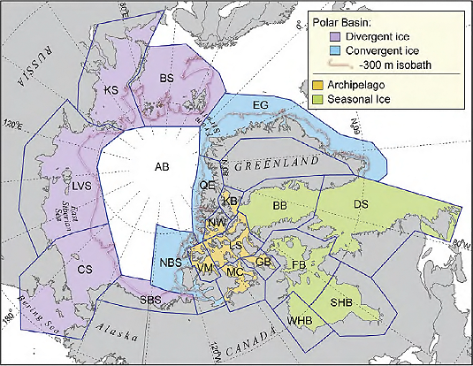

Map of polar bear subpopulations and ecoregions. Source: US Geological Survey, Public domain, via Wikimedia Commons. https://commons.wikimedia.org/wiki/File:Polar_bear_subpopulation_map.png

Because the bears will sometimes migrate from one country to another and monitoring them is frequently expensive and challenging, their population numbers are difficult to determine definitively.³

Ringed seals are the bears’ primary prey because they are the only seal to remain in the Arctic all year. To survive the winter, they make breathing holes in the ice. Bearded seals are their second most eaten prey because bearded seals migrate out of the Arctic Ocean for winter, then re-enter as the ice breaks up. But polar bears are very resourceful and will eat anything they can catch. They have also been known to eat dead fish, garbage, walrus, and reindeer. They eat other animals when seals are no longer available to them and will move from hunting near and on the ice to hunting on land, especially in the summer.

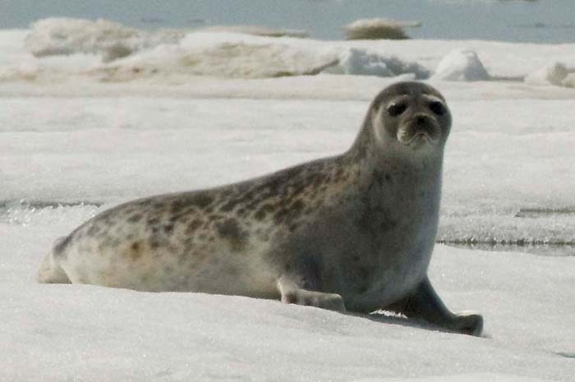

Ringed Seal. Source: NOAA Seal Survey, Public domain, via Wikimedia Commons. https://commons.wikimedia.org/wiki/File:Pusa_hispida_hispida_NOAA_1.jpg

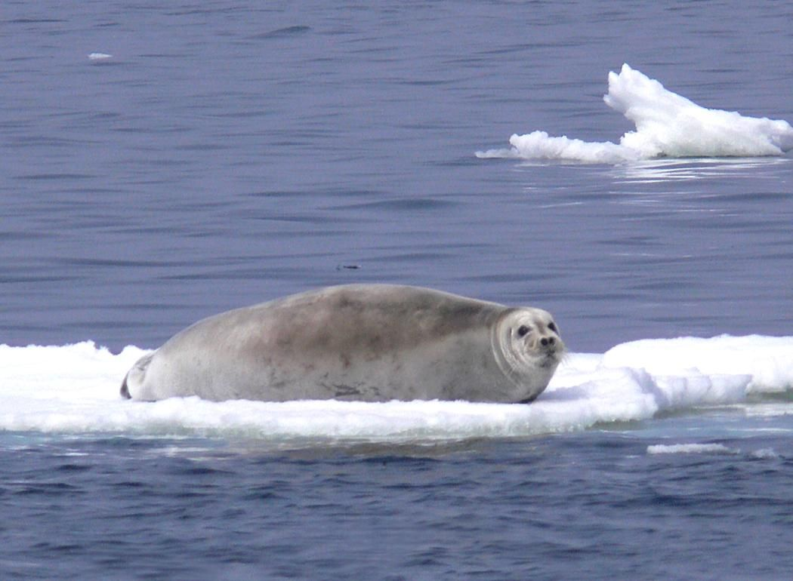

Bearded Seal. Source: Liz Labunski, U.S. Fish and Wildlife Service, Public domain, via Wikimedia Commons. https://commons.wikimedia.org/wiki/File:Bearded_seal_laying_on_ice.jpg

Polar bears will mate in spring, but gestation doesn’t start until the winter months. Over the winter, the female will stay inside her den made of snow and ice while she gestates and gives birth.⁴ The female will fast until they emerge from their den in March coinciding with when ringed seal pups are born.

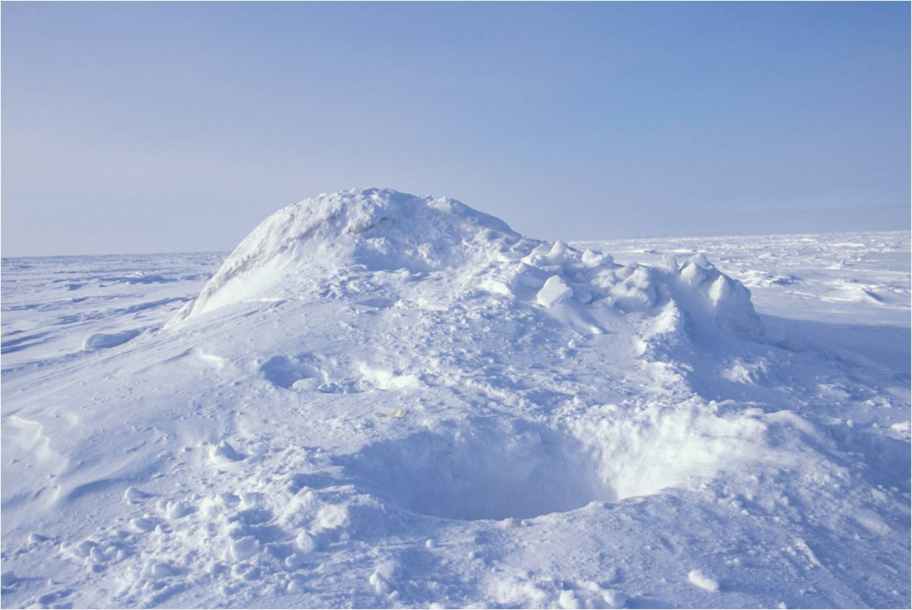

Ursus maritimus or polar bear den opening near the Alaska coast. Source: USFWSAlaska, Public domain, via Wikimedia Commons. https://commons.wikimedia.org/wiki/File:Polar_Bear_Den_Opening_(5165082172).jpg

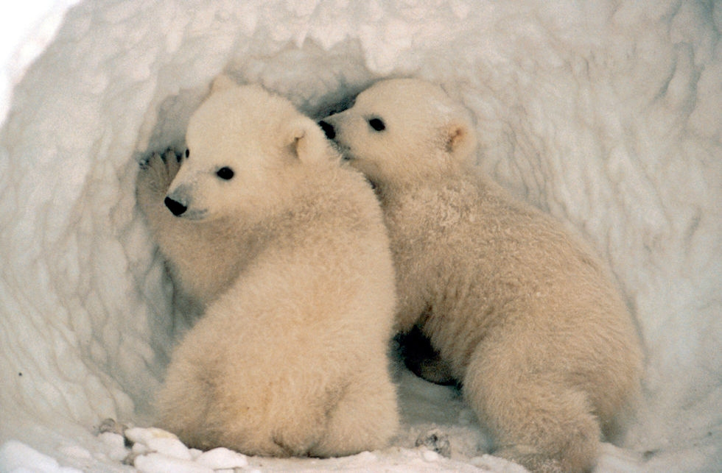

Polar Bear Cubs in den opening. Source: U.S. Fish and Wildlife Service Headquarters, Public domain, via Wikimedia Commons. https://commons.wikimedia.org/wiki/File:Polar_Bear_Cubs_(6383864173).jpg

She can have between one and three cubs in a litter. Cubs will stay with their mother for up to two years, during which time the mother can protect them in the den and, as they get older, teach them how to hunt. In the spring, during the months of April through July, the bears will venture out onto the melting ice to stalk and kill seals that have come onto the ice to molt. During the late winter and early spring months when seals have formed breathing holes in the ice, polar bears will crouch beside the hole and ambush them when they come to the surface to breathe.⁵ Bears are most successful when hunting baby seals and molting seals and double their weight during those 3-4 months. During the winter, catching a ringed seal at its breathing hole is far more difficult, causing bears’ hunting success to plummet. Pregnant females don’t bother hunting then and hibernate all winter. Despite all the winter ice, bears lose weight during the winter. The amount of ice available to bears is not a problem as evidenced by the loss of weight when there is plenty of winter ice.

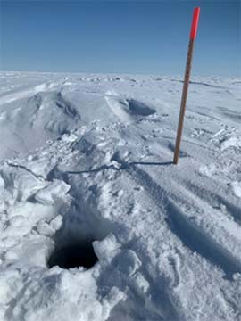

Ringed seal breathing hole open at the snow surface NMFS ESA/MMPA Permit No. 20466-01. Source: Alaska Department of Fish and Game. https://www.adfg.alaska.gov/index.cfm?adfg=marinemammalprogram.winterringedseal

In fact, polar bears fast from September through the middle of November. Pregnant females will fast until the birth of their cubs in December.⁴

There has been a lot of publicity stating that a reduction in the Arctic sea ice will cause a severe reduction in the population of polar bears and their health, however there is no evidence to support this position. These statements are based mostly on model predictions rather than empirical data as are the ratings by the International Union for Conservation of Nature (IUCN). In fact, polar bear numbers have greatly increased after the enactment of the Marine Mammal Protection Act (MMPA) and the Convention on International Trade in Endangered Species (CITES), indicating that most likely the biggest threat to polar bears is overhunting. A recent study has determined that despite a reduction of ice in both the Barents Sea and Chukchi Sea, the body conditions of both male and female bears has increased between 2004 and 2017.⁵ Indeed, as long as there is sea ice during their peak feeding season, the reduced ice pack has no effect on their ability to find food, including their major food source.⁶

It is important to note that each population of polar bears is unique and studied separately. Increased health of one population does not imply that all the populations are increasing or stable. However, according to data from the IUCN Polar Bear Specialist Group, of the populations of polar bears for which they have data, seven of the populations are either likely stable or likely increasing whereas only three of the populations have likely decreased.⁷

There are more factors than the amount of sea ice that determine the size and health of polar bear populations.⁸ One of these factors is the amount of food for polar bears, which is primarily seals. Seals eat fish, fish eat smaller organisms such as krill, and krill eat phytoplankton, which are small, photosynthetic organisms that float close to the surface of the ocean and are the primary source of food, or primary productivity, for the ocean. A recent report from NOAA⁹ states that “from 2003 to 2025, phytoplankton productivity spiked by 80% in the Eurasian Arctic, 34% in the Barents Sea, and 27% in Hudson Bay, and that plankton productivity in 2025 was higher than the 2003-22 average in eight of nine regions assessed across the Arctic.” The reduction of sea ice has allowed more sunlight to reach the surface of the ocean and has therefore increased the populations of organisms that comprise the primary food source for the ocean food chain. Below is a diagram that summarizes the relationships:

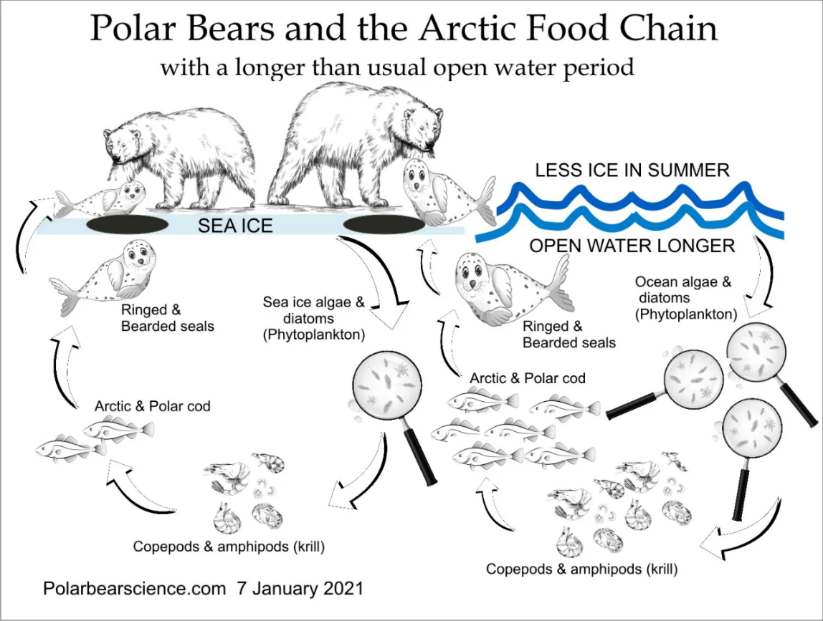

The determination of the polar bear’s status according to the IUCN Red List of Threatened Species is based in large part on computer models. According to the IUCN Polar Bear Specialist Group, their assessment of polar bears “included a comprehensive assessment of generation length (GL) for Polar Bears; development of a standardized sea-ice metric representing important habitat characteristics for the species; and population projections, over three Polar Bear generations, using computer simulation and statistical models representing alternative relationships between sea ice and Polar Bear abundance.”¹⁰ (Emphasis added.) The IUCN also base their polar bear status determinations on the probability of the population increasing or decreasing, with no mention at all of any empirical data. This fact would explain why direct measures of polar bear health and population size do not seem to agree with the probabilities as predicted by their computer models.

References
- North Pole Climate, https://en.climate-data.org/north-america/united-states-of-america/alaska/north-pole-15898/
- Polar Bear, https://www.britannica.com/animal/polar-bear
- Karyn D. Rode, Ryan R. Wilson, Justin A. Crawford, Lori T. Quakenbush. “Identifying indicators of polar bear population status.” Ecological Indicators, Volume 159, 2024, https://doi.org/10.1016/j.ecolind.2024.111638.
- M.A. Ramsay, Ian Stirling. “Reproductive biology and ecology of female polar bears (Ursus maritimus).” Journal of Zoology, Lond. (1988) 214, 601-634.
- The Icy Hunt: Polar Bear Diet and Feeding Habits. https://polarbears.com/information-about-polar-bears/the-icy-hunt-polar-bears-diet-and-feeding-habits/
- Lippold, A., Bourgeon, S., Aars, J., Andersen, M., Polder, A., Lyche, J.L., Bytingsvik, J., Jenssen, B.M., Derocher, A.E., Welker, J.M. and Routti, H. 2019. “Temporal trends of persistent organic pollutants in Barents Sea polar bears (Ursus maritimus) in relation to changes in feeding habits and body condition.” Environmental Science and Technology 53(2):984-995.
- Polar Bears International, https://polarbearsinternational.org/polar-bears-changing-arctic/polar-bear-facts/status/
- Aars, J., Ieno, E.N., Andersen, M. et al. 2026. “Body condition among Svalbard Polar bears Ursus maritimus during a period of rapid loss of sea ice.” Scientific Reports 16, 2182. https://doi.org/10.1038/s41598-025-33227-9
- NOAA, Arctic Report Card: Update for 2025. https://arctic.noaa.gov/report-card/report-card-2025/
- IUCN Red List, Summary of the 2015 polar bear assessment. https://www.iucn-pbsg.org/iucn-redlist/

Suggested Activities
- Compare how animals modify their environment to help with their survival. Female polar bears create snow dens to protect themselves and their young during birthing and the first few months of life from predators and cold weather. Have the students make a personal list of animals that modify their environment to help them survive. Examples may include fox and coyote dens, bird nests, etc. Have the students find pictures online of their examples and put them together in a book. Have older students write the name of the animal and how the picture shows the animal modifying its behavior.
- Have students identify all the actions a mother polar bear takes to protect and raise her young. This list can be written on a sheet of paper or a notebook. Have the students get ideas from the book and the background information. Then have the students pick an animal other than a polar bear, preferably their favorite animal or one that lives close by and have them make a similar list for their chosen animal. Ask the students to compare and contrast the strategies taken by the two mothers to protect and teach their young.

- Where is Earth’s water?

Part 1:
Make and distribute cards labeled with Earth’s water reservoirs (oceans, glaciers, groundwater, rivers, lakes, atmosphere) and estimated percentages. They should sort, order, and glue them onto a visual "water on Earth" diagram, then discuss why so little water is drinkable and accessible.

Part 2:
Make a scale model with measuring cups: Using a 1-liter container to represent all of Earth's water, students measure out proportional amounts using standard units (mL): ~970 mL for salt water, ~28 mL for ice caps, ~2 mL for groundwater, and less than 1 mL for all surface fresh water combined. The shock of seeing nearly empty cups for "usable" fresh water drives home the concept. A water or soda bottle can be used for the 1-liter container. An assortment of graduated cylinders to use to measure out water amounts can be purchased on Amazon.com: https://www.amazon.com/s?k=100+ml+graduated+cylinder
- Create climate graph for your home location. A climate graph for the North Pole is included in the background information of this lesson plan. These graphs are easy to create with data obtained online from various weather apps. In each of these graphs, the months are charted on the bottom or x-axis. This is the variable that the student chooses to manipulate. Then two lines will be drawn on the graph (or a combination of a bar graph and a line graph can be used as shown in the illustration). Traditionally, the temperature is put on the left vertical axis or y-axis (the variable that is measured), and the amount of precipitation is put on the right vertical axis. Red is usually used to represent temperature, and blue is used to represent precipitation. Either ask the students to find the temperature and precipitation data on their own or give them the information in a table to graph. After drawing the graphs, ask the students to compare and contrast their climate graph with the one of the North Pole. Alternatively, each student can be assigned a different city to draw a climate graph for, then all the graphs can be presented to the class and they can discuss how and why they are different.
- How does transparent fur help polar bears to stay warmer than opaque fur? Most animals have opaque fur that acts as an insulator against temperature extremes. They will grow thick fur coats in the winter and shed them as it gets warmer. However, polar bears use a combination of transparent fur and black skin to maximize the absorption of energy from the Sun.
Materials: light source; regular thermometer or an infrared thermometer gun (https://www.amazon.com/s?k=infrared+thermometer+gun&crid=1N8IET5Z0SD6M&sprefix=infrare%2Caps%2C269&ref=nb_sb_ss_p13n-expert-pd-ops-ranker_ci_hl-bn-left_1_7); transparent material such as plastic wrap, bubble wrap, or similar substance; opaque material such as a piece of card-stock paper or construction paper; black material such as construction paper, black fabric, or faux fur.
Procedure: First, make sure the students understand the difference between opaque and translucent. Second, discuss how and why black surfaces absorb more heat than white or light-colored surfaces. Last, make sure they understand the concept of heat insulating materials. Once the students understand these concepts, talk about the fact that polar bears have translucent fur and black skin. Have them brainstorm reasons why polar bears have this adaptation and do not have opaque fur like most animals.
Divide the students into groups and have them design an experiment that would demonstrate how translucent fur over black skin would keep a polar bear warmer than opaque fur on black skin. If you wish, you can give them a list of the materials in advance and ask them how they would use them to design an experiment.
The students’ design should include the following:

- A testable hypothesis (the experimental group will be warmer, will not be warmer, or there will be no difference)
- A control group: the experiment that uses opaque fur
- An experimental group: the experiment that uses translucent “fur”
- Constants: all the factors that are the same in both experiments
- Have the students identify the one variable: the opaque or translucent “fur”
- Data collection: the students should describe how they plan to determine whether the temperature is different or not. They should also determine how they plan to take measurements and how often, and when they can stop taking measurements.
- A data table: the students should record their measurements in a notebook or on a piece of paper.
- A graph: the students should graph their data. Make sure they draw their graph correctly. The graph should include numbers, units, labels (time and temperature), and a brief description of what has been graphed. Make sure the independent variable (time, which is the variable they control or manipulate) is on the bottom or x-axis and the dependent variable (temperature, which is the variable they measure) is on the vertical or y-axis.
- A conclusion: the students may either give a presentation to the class or independently write their own conclusions based on their data. They should also give a clear explanation as to the reason they reached this conclusion and a possible explanation of the reason for the results. A short error analysis (what they could do better next time) may be included.
- Interpreting graphs and charts. An important skill in science is to be able to collect data and then determine what it means and what conclusions one can draw from the results. Below is a data table that records the ages of female polar bears and the number of their cubs in Manitoba, measured in the spring and fall, from the years 1966 to 1985. At first, the chart seems a bit overwhelming, and it is difficult to infer any information from it. This exercise will help students analyze data tables and use them to create graphs to illustrate the same information.
Begin by asking students the following questions. It is recommended that individual students do their own calculations.

- At what age do female polar bears begin to have cubs?
- What is the oldest age a polar bear was measured to have had cubs?
- What percentage of bears at each age had cubs?
- Calculate the percentage with cubs of each age group of bears that have cubs. (If necessary, review with students how to calculate percentages.)
- Calculate for each age group the percentage of females with single cubs, twins, triplets, and yearlings aged 1, 2, and 3 of bears with cubs.
- Which age group had the largest percentage of cubs? Which group had the largest percentage of single cubs? Twins? Triplets? Yearlings?
- What appears to be the prime cub-bearing ages for female polar bears?
- Why is it important, when comparing the number of cubs per female, to use percentages instead of the actual number of cubs?
Once the students have calculated percentages, the following graphs should be easy to construct. Remember, the independent variable (age of the polar bear, which is manipulated) goes on the x-axis and the dependent variable (number of cubs, which is measured) goes on the y-axis.
- Construct a graph that shows the relationship between the age of female polar bears vs the total number of cubs. Write a short title with a description of your graph (see the title of the chart below as an example). Which age range has the largest number of cubs?
- Construct a graph that shows the relationship between the age of bears with cubs and the number of single cubs. Draw this as a single line. Draw another line that shows the relationship between bears with cubs and the number of twins, and another line that shows the relationship between the number of bears with cubs and the number of triplets. Be sure to label each line. Using this graph, answer the following questions: Which age group had the most triplets? Twins? Single cubs?
- Construct a graph that shows the relationship between the age of bears with cubs and the number of yearlings that are 1-year old. Do the same for yearlings age 2-years and 3-years. Construct this graph in the same way as the one above was constructed. Which age group of female bears has the most yearlings? Which had the most 2-year-olds? Which had the most 3-year-olds? Do female bears take care of cubs and yearlings at the same time? Why might this be?
- Is it more common for female polar bears to have single cubs, twins, or triplets? What is your evidence?
- Is it more common for older bears or younger bears to have cubs but no yearlings? Yearlings but no cubs? What is your evidence?

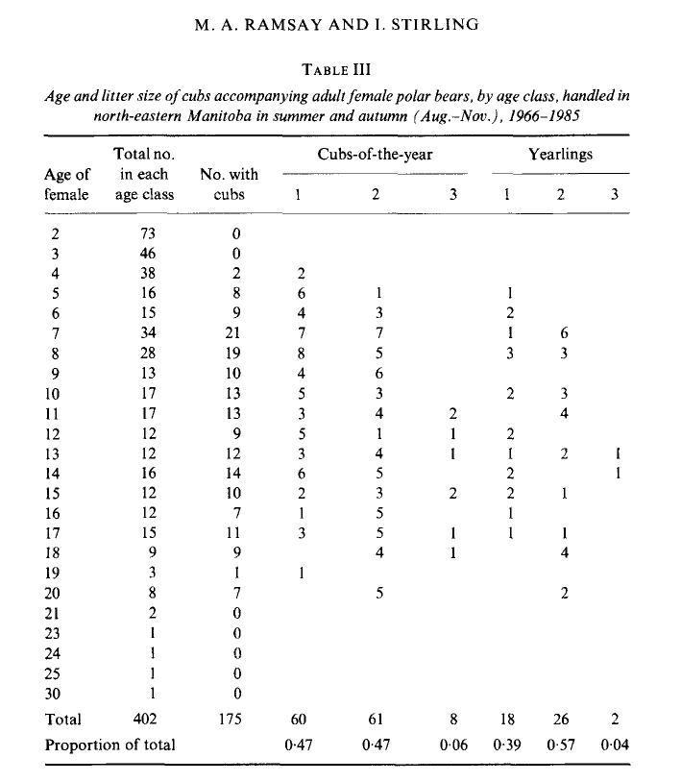

Formative and Summative Assessments
- How are polar bears different from other bears and where do they live?
- What is the weather like where polar bears live?
- Describe where a polar bear cub lives shortly after it is born.
- What do polar bears eat? Why does their diet change during the year?
- What features does a polar bear have that allow it to survive during the harsh winters?
- What time of year do polar bears eat seals and why are they not available year-round?
- Why doesn’t sea ice cover affect the bears’ diet during the summer months?
- What are plankton, why are they important to the food chain, and why do they grow more abundant with a reduction of summer sea ice?
- Why is a computer model prediction less accurate than measured, empirical data?

Next Generation Science Standards (NGSS) Learning Objectives:

The standards here are written exactly as they are written in the NGSS.

K-LS1-1 From Molecules to Organisms: Structures and Processes. Students who demonstrate understanding can:

K-LS1-1. Use observations to describe patterns of what plants and animals (including humans) need to survive. [Clarification Statement: Examples of patterns could include that animals need to take in food but plants do not; the different kinds of food needed by different types of animals; the requirement of plants to have light; and, that all living things need water.] This standard includes the following Disciplinary Core Ideas:

LS1.C: Organization for Matter and Energy Flow in Organisms
- All animals need food in order to live and grow. They obtain their food from plants or from other animals. Plants need water and light to live and grow.

K-ESS2-2 Earth's Systems. Students who demonstrate understanding can:

K-ESS2-2. Construct an argument supported by evidence for how plants and animals (including humans) can change the environment to meet their needs. [Clarification Statement: Examples of plants and animals changing their environment could include a squirrel digs in the ground to hide its food and tree roots can break concrete.] This standard includes the following Disciplinary Core Ideas:

ESS2.E: Biogeology
- Plants and animals can change their environment.

K-ESS3-1 Earth and Human Activity. Students who demonstrate understanding can:

K-ESS3-1. Use a model to represent the relationship between the needs of different plants and animals (including humans) and the places they live. [Clarification Statement: Examples of relationships could include that deer eat buds and leaves, therefore, they usually live in forested areas; and, grasses need sunlight so they often grow in meadows. Plants, animals, and their surroundings make up a system.] This standard includes the following Disciplinary Core Ideas:

ESS3.A: Natural Resources
- Living things need water, air, and resources from the land, and they live in places that have the things they need. Humans use natural resources for everything they do.

1-LS1-2 From Molecules to Organisms: Structures and Processes. Students who demonstrate understanding can:

1-LS1-2. Read texts and use media to determine patterns in behavior of parents and offspring that help offspring survive. [Clarification Statement: Examples of patterns of behaviors could include the signals that offspring make (such as crying, cheeping, and other vocalizations) and the responses of the parents (such as feeding, comforting, and protecting the offspring).] This standard includes the following Disciplinary Core Ideas:

LS1.B: Growth and Development of Organisms
- Adult plants and animals can have young. In many kinds of animals, parents and the offspring themselves engage in behaviors that help the offspring to survive.

2-LS4-1 Biological Evolution: Unity and Diversity. Students who demonstrate understanding can:

2-LS4-1. Make observations of plants and animals to compare the diversity of life in different habitats. [Clarification Statement: Emphasis is on the diversity of living things in each of a variety of different habitats.] [Assessment Boundary: Assessment does not include specific animal and plant names in specific habitats.] This standard includes the following Disciplinary Core Ideas:

LS4.D: Biodiversity and Humans
- There are many different kinds of living things in any area, and they exist in different places on land and in water.

2-ESS2-3 Earth's Systems. Students who demonstrate understanding can:

2-ESS2-3. Obtain information to identify where water is found on Earth and that it can be solid or liquid. This standard includes the following Disciplinary Core Ideas:

ESS2.C: The Roles of Water in Earth’s Surface Processes
- Water is found in the ocean, rivers, lakes, and ponds. Water exists as solid ice and in liquid form.

3-LS4-3 Biological Evolution: Unity and Diversity. Students who demonstrate understanding can:

3-LS4-3. Construct an argument with evidence that in a particular habitat some organisms can survive well, some survive less well, and some cannot survive at all. [Clarification Statement: Examples of evidence could include needs and characteristics of the organisms and habitats involved. The organisms and their habitat make up a system in which the parts depend on each other.] This standard includes the following Disciplinary Core Ideas:

LS4.C: Adaptation
- For any particular environment, some kinds of organisms survive well, some survive less well, and some cannot survive at all.

3-ESS2-1 Earth's Systems. Students who demonstrate understanding can:

3-ESS2-1. Represent data in tables and graphical displays to describe typical weather conditions expected during a particular season. [Clarification Statement: Examples of data could include average temperature, precipitation, and wind direction.] [Assessment Boundary: Assessment of graphical displays is limited to pictographs and bar graphs. Assessment does not include climate change.] This standard includes the following Disciplinary Core Ideas:

ESS2.D: Weather and Climate
- Scientists record patterns of the weather across different times and areas so that they can make predictions about what kind of weather might happen next.

4-LS1-1 From Molecules to Organisms: Structures and Processes. Students who demonstrate understanding can:

4-LS1-1. Construct an argument that plants and animals have internal and external structures that function to support survival, growth, behavior, and reproduction. [Clarification Statement: Examples of structures could include thorns, stems, roots, colored petals, heart, stomach, lung, brain, and skin.] This standard includes the following Disciplinary Core Ideas:

LS1.A: Structure and Function
- Plants and animals have both internal and external structures that serve various functions in growth, survival, behavior, and reproduction.

5-ESS2-2 Earth's Systems. Students who demonstrate understanding can:

5-ESS2-2. Describe and graph the amounts of salt water and fresh water in various reservoirs to provide evidence about the distribution of water on Earth. [Assessment Boundary: Assessment is limited to oceans, lakes, rivers, glaciers, ground water, and polar ice caps, and does not include the atmosphere.] This standard includes the following Disciplinary Core Ideas:

ESS2.C: The Roles of Water in Earth’s Surface Processes
- Nearly all of Earth’s available water is in the ocean. Most fresh water is in glaciers or underground; only a tiny fraction is in streams, lakes, wetlands, and the atmosphere.

MS-PS3-3 Energy. Students who demonstrate understanding can:

MS-PS3-3. Apply scientific principles to design, construct, and test a device that either minimizes or maximizes thermal energy transfer.* [Clarification Statement: Examples of devices could include an insulated box, a solar cooker, and a Styrofoam cup.] This standard includes the following Disciplinary Core Ideas:

PS3.A: Definitions of Energy
- Temperature is a measure of the average kinetic energy of particles of matter. The relationship between the temperature and the total energy of a system depends on the types, states, and amounts of matter present.

PS3.B: Conservation of Energy and Energy Transfer
- Energy is spontaneously transferred out of hotter regions or objects and into colder ones.

ETS1.A: Defining and Delimiting an Engineering Problem
- The more precisely a design task’s criteria and constraints can be defined, the more likely it is that the designed solution will be successful. Specification of constraints includes consideration of scientific principles and other relevant knowledge that is likely to limit possible solutions. (secondary)

ETS1.B: Developing Possible Solutions
- A solution needs to be tested, and then modified on the basis of the test results in order to improve it. There are systematic processes for evaluating solutions with respect to how well they meet criteria and constraints of a problem. (secondary)

MS-LS1-4 From Molecules to Organisms: Structures and Processes. Students who demonstrate understanding can:

MS-LS1-4. Use argument based on empirical evidence and scientific reasoning to support an explanation for how characteristic animal behaviors and specialized plant structures affect the probability of successful reproduction of animals and plants respectively. [Clarification Statement: Examples of behaviors that affect the probability of animal reproduction could include nest building to protect young from cold, herding of animals to protect young from predators, and vocalization of animals and colorful plumage to attract mates for breeding. Examples of animal behaviors that affect the probability of plant reproduction could include transferring pollen or seeds, and creating conditions for seed germination and growth. Examples of plant structures could include bright flowers attracting butterflies that transfer pollen, flower nectar and odors that attract insects that transfer pollen, and hard shells on nuts that squirrels bury.] This standard includes the following Disciplinary Core Ideas:

LS1.B: Growth and Development of Organisms
- Animals engage in characteristic behaviors that increase the odds of reproduction.
- Plants reproduce in a variety of ways, sometimes depending on animal behavior and specialized features for reproduction.

MS-LS2-2 Ecosystems: Interactions, Energy, and Dynamics. Students who demonstrate understanding can:

MS-LS2-2. Construct an explanation that predicts patterns of interactions among organisms across multiple ecosystems. [Clarification Statement: Emphasis is on predicting consistent patterns of interactions in different ecosystems in terms of the relationships among and between organisms and abiotic components of ecosystems. Examples of types of interactions could include competitive, predatory, and mutually beneficial.] This standard includes the following Disciplinary Core Ideas:

LS2.A: Interdependent Relationships in Ecosystems
- Similarly, predatory interactions may reduce the number of organisms or eliminate whole populations of organisms. Mutually beneficial interactions, in contrast, may become so interdependent that each organism requires the other for survival. Although the species involved in these competitive, predatory, and mutually beneficial interactions vary across ecosystems, the patterns of interactions of organisms with their environments, both living and nonliving, are shared.

Source: https://www.nextgenscience.org

CO2 Coalition Senior Education Advisor Sharon R. Camp, Ph.D., Analytical Chemistry; B.S., Geology

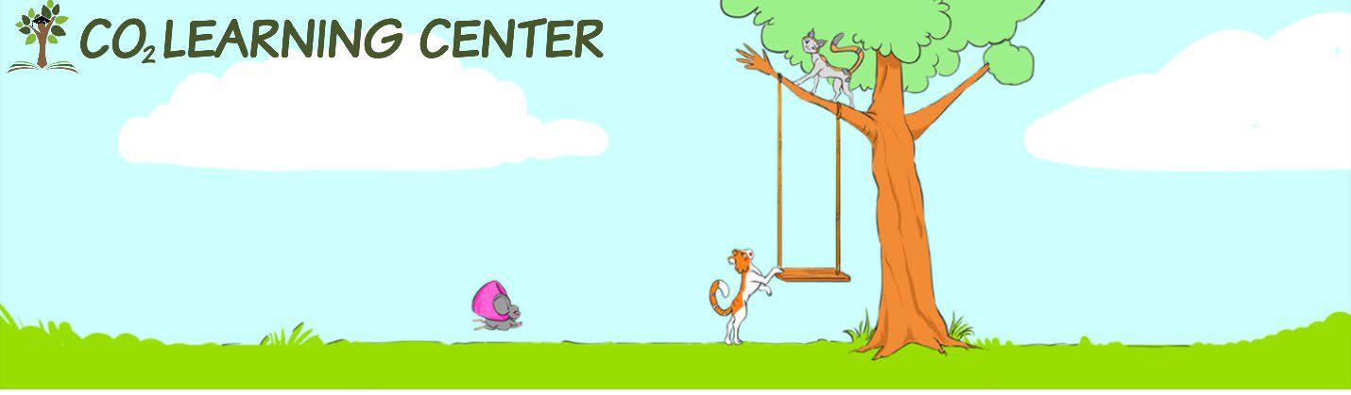

What is the CO₂ Coalition?
The CO2 Coalition was established in 2015 as a 501(c)(3) (an educational nonprofit) for the purpose of educating thought leaders, policymakers and the public about the important contribution made by carbon dioxide to our lives and the economy.
The CO2 Coalition is a group of top scientists, engineers and energy experts who study and report on the important contribution made by carbon dioxide to our lives and the economy.
Learn more at CO2Coalition.org and CO2LearningCenter.com.

